SDK and System Resources of
B3VDU

STELS PART NO: 2200298216

Change Index.
Index | Date | Amendment contents | Version | Person
1 | 08 July2022 | First Copy for release | 1.0.1 | Chen Yong

Table of Contents

1 Scope 4
2 System 4
3 Environment 5
3.1 VDU 5
3.2 Programming computer 5
4 B3VDU system resources 5
4.1 External interface 5
4.1.1 LCD 5
4.1.2 UART 6
4.1.3 Ethernet 6
4.1.4Keypad 6
4.1.5 SDI Input 6
4.1.6 CAN 6
4.2 Internal Interface 7
4.2.1 I2C 7
4.2.2 Video Registers 7
4.2.3 OSD Memory 8
4.2.4 iio sensor 8
4.2.5 Watchdog 8
5 Programming 8
5.1 A simple firmware 8
5.1.1 Edit 8
5.1.2 Compile 10
5.1.3 Run firmware 10

1 Scope
This document stipulates programming and system resources setup procedures for Video Display Unit (abbreviated as VDU B3 here after). This document will be used as a guideline to system resources and programming of VDU B3 in according to the technical specification requirements.

2 System
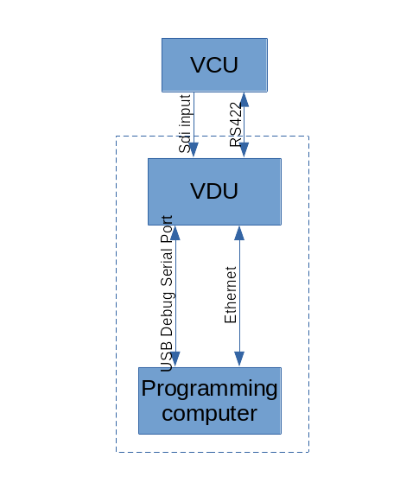

Figure is the full system physical connection . The devices and linking for programming are in the dotted line box.

3 Environment

3.1 VDU
Default setting:
- static IP (192.168.9.115)
- username: root
- password: root
The sftp client software will be used for upload and download the files to the VDU.
The “Tera Team” test software to control the VDU with the serial port debug application.
The user also can log in and control the VDU with putty or ssh.

3.2 Programming computer
- This computer is for programming the software for the VDU. The Ubuntu (20.04) is required and verified to work.
- This computer has the same subnet IP address with the VDU.
- The user need install the requirement software eg Filezilla (sftp client), GTKTerm (serial debug) or ssh for downloading, uploading and debugging the VDU files.
- The user run sdk.sh (from teamone) to install the sdk compiler.
- <your-sdk-dir>/environment-setup-cortexa72-cortexa53-xilinx-linux includes the environment setup for the compiler. The user need setup the environment of the compiler based on their SDK requirement.

4 B3VDU system resources

4.1 External interface

4.1.1 LCD
LVDS: LCD video data signal.
LCD DIM PWM output: adjust LCD bright.
output control reference 4.2.2

4.1.2 UART
This port is link to the VDU for the VDU switching command.
Format: TIA/EIA-422
Device name: /dev/ttySC1
working mode: Duplex
flow control: no

4.1.3 Ethernet
10/100/1000 BASE-T

4.1.4Keypad
Key No | Gpio port | Key name | Linux code
KEY_DIN_1 | <axi_gpio_0 0> | key1 | KEY_1(2) | Trailer ?
KEY_DIN_2 | <axi_gpio_0 1> | key2 | KEY_2(3) | Reverse Gear
KEY_DIN_3 | <axi_gpio_0 2> | key3 | KEY_3(4) | Forward Gear
KEY_DIN_4 | <axi_gpio_0 3> | key4 | KEY_4(5) | TBD
KEY_DIN_5 | <axi_gpio_0 4> | key5 | KEY_5(6) | TBD
KEY_DIN_6 | <axi_gpio_0 5> | key6 | KEY_6(7) | TBD
KEY_DIN_7 | <axi_gpio_0 6> | key7 | KEY_7(8) | TBD
KEY_DIN_8 | <axi_gpio_0 7> | key8 | KEY_8(9) | TBD

4.1.5 SDI Input
control reference 4.2.2

4.1.6 CAN
Ifname: can0
Spare device

4.2 Internal Interface

4.2.1 I2C
device name: /dev/i2c-0
slave chip: mb85rc256vfp slave address: 0x50
description: log data storage

4.2.2 Video Registers
Registers Physical address: 0xa0000000
Registers Physical size: 0x2000
Registers data: 32bits
registers | W/R | items | value
0x0000 | W/R | brightness | 0 - 100
0x0004 | W/R | NVG brightness | 0 - 100  default 10
0x0008 | W/R | NVG mode | 0 – normal mode  1 – NVG mode
0x000C | W/R | auto_manu | 0 – auto select video  1 – manual select video
0x0010 | W/R | osdCtrl | 0 – no OSD  1 – overlay OSD
0x0014 | W/R | video source | 0 – video source 0  1 - video source 1
0x0018 | W/R | contrast value | 0 – 100 convert to -255 ~ 255  (x- 50) x 255 /50
0x001C | W/R | color value | 0 – 100 convert to -255 ~ 255  (x- 50) x 255 /50
0x0100 | read only | status | bit 3-0 -- sdi 4 inputs: 0 normal, 1 no signal  bit 4 -- ddr read: 0 normal, 1 no read operation  bit 5 -- ddr write: 0 normal, 1 no write operation  bit 7-6 – display: 00 normal, 01 no signal, 10 error

4.2.3 OSD Memory
OSD physical address: 0x70000000
OSD Resolution: 1920x1080
OSD format: RGBA32

4.2.4 iio sensor
CPU:/sys/bus/iio/devices/iio\:device0
Power Current Sensor:/sys/bus/iio/devices/iio\:device1

4.2.5 Watchdog
Device: /dev/watchdog0, /dev/watchdog1
watchdog0 is controlled by OS.
Watchdog1 can be controlled by the user.

5 Programming

5.1 A simple firmware

5.1.1 Edit
Install Atom as the SDK editor. Install Atom requirement plugin.
Create the Project Folder and Add this project folder into the Atom.
create a new file ‘Makefile’ and a folder ‘src’ in this project folder.
Create a source file ‘main.c’ in the folder ‘src’.
edit Makefile:
TARGET := $(notdir $(CURDIR))
CSOURCES := $(wildcard src/*.c)
COBJECTS := $(CSOURCES:%.c=%.o)
CPPSOURCES := $(wildcard src/*.cpp)
CPPOBJECTS := $(CPPSOURCES:%.cpp=%.o)
CFLAGS := -O
LDFLAGS :=
LIBS :=
.PHONY: $(TARGET)

$(TARGET): $(COBJECTS) $(CPPOBJECTS)
$(CXX) -o $@ $^ $(LDFLAGS) $(LIBS)

$(COBJECTS): %.o: %.c
$(CC) $(CFLAGS) -o $@ -c $<

$(CPPOBJECTS): %.o: %.cpp
$(CXX) $(CFLAGS) -o $@ -c $<
clean:
rm -rf *~ .dep $(COBJECTS) $(CPPOBJECTS) $(TARGET)

edit the main.c:
#include <stdio.h>
int main()
{
printf(“hello world!\n”);
return 0;
}

5.1.2 Compile
Open Terminal and Go to your project folder. Run “make”.
Then you get an executable file ‘<your-project-folder>’ in <your-project-folder>.

5.1.3 Run Firmware
- Download the executable file to /usr/local/bin in the VDU with the sftp client software
- Open GTKTerm and connect to the VDU with the USB debug port.
(e.g /dev/ttyUSB0)
- Disable the original VDU firmware in /etc/init.d/loaduserapp.sh and reboot the VDU
- go to the folder /usr/local/bin and run your application

