VIDEO DISPLAY UNIT B3

STELS PART NO: 2200298216

ACCEPTANCE TEST PLAN

APPROVED BY
NAME | DESIGNATION | SIGNATURE | EFFECTIVE DATE
JOB KARHTY | ENGINEER |  | 27 APRIL 2022
LUO ZUKANG | ENGINEER |  | 27 APRIL 2022
MR.MA ZAI HANG | MANAGER |  | 27 APRIL 2022

Change Index.
Index | Date | Amendment contents | Person
1 | 31.03.2022 | First Copy for release | Gan Chee Hong
2 | 27.04.2022 | Fine tune the test procedure | Karthy

TABLE OF CONTENTS
1. Overview 4
2. Test Equipment, Setting and Matrix 4
2.1 Test Setup 5
2.2 Control Button Software Test 5
3 Test Procedure 8
3.1 Physical Specification 8
3.1.1 Visual Inspection 8
3.1.2 Physical Characteristics Measurements 8
3.2 Operating Power 8
3.3 System Start up Test 9
3.4 Reverse Polarity Protection Test 9
3.5 Video Latency Test 9
3.6 Video IO characteristics 9
3.7 Video Flickering Test 9
3.8 Image Smearing Test 10
3.9 LCD Pixel Defects 10
3.10 Display Resolution Test 10
3.11 Display Contrast Test 11
3.12 Display Brightness Test 12
3.13 VDU IO operation test 13
3.14 RS422 Control Test 13
3.15 USB Debugging port Test 13
3.16 Ethernet Connection Test 14
3.17 System BIT Test 14
System BIT Test 14
3.18 Degraded or Emergency operation mode Test 15
4.0 Visual Inspection & Documentation 15

Overview
This document stipulates and the functional qualification test setup procedures for Video Display Unit (abbreviated as VDU B3 here after). This document will be used as a guideline to qualify the operational functional and characteristics of VDU B3 in according to the technical specification requirement and defined in the document of SSRS REQ-328-JH-0005_A_REV_3 for Video Display Unit B3.

Test Equipment, Setting and Matrix
The following equipment and facilities are required for testing.
- DC power supply, output range from 18V ~ 32V, current rating at 2A@24VDC
- A PC or Laptop, with test software.
- Oscilloscope is to measure the ripples of the camera outputs.
- Video signal generator is to generate 4 channels HD-SDI signals / SD-SDI signals.
- HD-SDI Camera
- Ruler
- Weighing device

2.1 Test Setup

2.2 Control Button Software Test
The Phyton test software will be used for VDU B3 control button to test the functional key and responding for the results according to the test procedure 3.13.
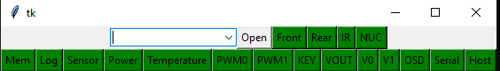
Figure:2 Test Software

Table 1. VDU B3 Characteristics and functions
S/N | Category |  |  | Characteristics | Test Procedure & Test Method
1 | Physical specifications
1 | Visual inspection |  |  | Refer to Mechanical Drawing | Procedure 3.1
1 | Physical Characteristics Measurement
1 | External dimension of Unit ( L x W x H) |  |  | 220mm x 150mm x 65mm | Procedure 3.1
1 | Weight |  |  | < 2 kg | Procedure 3.1
1 | Mounting dimension |  |  | Refer Mechanical drawing | Procedure 3.1
2 | Electrical specifications
2 | Input Vehicle Power supply | Operating voltage range |  | 18V ~ 32V | Procedure 3.2
2 | Input Vehicle Power supply | Peak Current rating |  | <2A for <1sec @ 24VDC | Procedure 3.2
2 | Input Vehicle Power supply | Continuous current rating |  | <1A @ 24VDC | Procedure 3.2
3 | System Start-up time |  |  | <20S | Procedure 3.3
4 | Reverse Polarity Test |  |  | 0A | Procedure 3.4
5 | Video Latency test |  |  | Expected results <50ms | Procedure 3.5
6 | Video IO characteristics
6 | Digital video input x 2 CH. |  | Resolution | SD video, 720x576pixels@25fps  HD video, 1920x1080pixels@30fps  All in SMPTE format | Procedure 3.6
6 |  |  | Data format |  | Procedure 3.6
6 |  |  | Frame Rate |  | Procedure 3.6
7 | Video flickering test |  |  | Observe the video no flicker on the LCD | Procedure 3.7
8 | Video Smearing test |  |  | Observe the video no smearing on the LCD | Procedure 3.8
9 | LCD Pixel Defects |  |  | To Check the LCD pixel defects | Procedure 3.9
10 | Video Resolution test |  |  | To check the Resolution. | Procedure 3.10
11 | Video contrast test |  |  | To check the Contrast. | Procedure 3.11
12 | Video Brightness test |  |  | To check the brightness | Procedure 3.12
12 | Control Buttons |  |  |  | Procedure 3.13
12.1 | 1. Front Camera view toggle. |  |  | Press the button to front mode. | Procedure 3.13
12.2 | 2. Rear Camera view toggle. |  |  | Press the button to Rear mode. | Procedure 3.13
12.3 | 3.IR illuminator ON/OFF toggle. |  |  | Press the button to IR mode. | Procedure 3.13
12.4 | 4. NUC trigger. |  |  | Press the NUC button to check. | Procedure 3.13
12.5 | 5. Night Mode toggle. |  |  | Press the Button to night Mode. | Procedure 3.13
S/N | Category |  |  | Characteristics | Test Procedure & Test Method
12.6 | 6. Dimmer “- “button. |  |  | LCD backlight dimmer, brightness number decrease
12.7 | 7. Brightness “+” button. |  |  | LCD backlight brighter, brightness number increase.
12.8 | 8. Menu. |  |  | Press the Button to check functions settings.
12.9 | 9. Power Button. |  |  | Press ON/OFF toggle.2 sec Holding default on.
13 | RS422 control test |  |  | Phyton software to conduct the test to RS422 port. | Procedure 3.14
14 | USB Debugging port test |  |  | Tera Team software to conduct the test to USB port. | Procedure 3.15
15 | Ethernet connection |  |  | Laptop to observe the Ethernet speed | Procedure 3.16
16 | System BIT test |  |  | Check VDU B3 ID and firmware version | Procedure 3.17
17 | Degraded or Emergency Operation Mode test |  | Disconnect the Video input A | NO SIGNAL Blue screen when disconnected.  Normal operation when connected. | Procedure 3.18
17 |  |  | Disconnect the Video input B |  | Procedure 3.18
18 | Visual Inspection & Documentation |  |  | Software version & E Box | Procedure 4.0

Test Procedure
The VDU B3 Box shall be completely assembled and must ensure the box in good condition to support for testing.
The software version 1.0.1 should be programmed promptly in the memory of VDU B3 Box.
Confirm the harness cables under working condition.

3.1 Physical Specification

3.1.1 Visual Inspection
- External outlook check, the box should be clear without any rust. The connectors should be secured properly on the box. The external painting / coating surface should be clean without scratch or dirties on its surface
- All components should be located on the correct position with correct orientation, without any damage or loose.
- The screws on the surface should be secured at respective level. Secured torque check should be conducted if necessary.

3.1.2 Physical Characteristics Measurements
- Physical external dimension size (W x H x D)
- Physical mass of the VDU B3 assemblies
- Mounting dimension of the boxes
- Record the result in Appendix 2.

3.2 Operating Power
Before power on the DC power supply, set voltage 28V at current rating 3A (Figure1).
- Power on the power supply.
- Adjust the DC power supply voltage to 18V, check that the VDU B3 remain in operation.
- Adjust the DC power supply voltage to 32V, check that the VDU B3 remain in operation.
- Adjust the DC power supply voltage to 28V, check that the VDU B3 remain in operation.
- Record the result in Appendix 2.

3.3 System Start up Test
This test shall be conducted at 28VDC
- Start the stop watch and power up the system in the same time.
- The time is counting when the system power up at the end. Stop the stop watch while system is connected.
- The result shall be <20sec.
- Record the result

3.4 Reverse Polarity Protection Test
To check the reverse polarity Protection test.
- Change the negative input to Vin+ and positive input to Vin -.
- Result current should be =0mA.

3.5 Video Latency Test
Using a signal generator to generate a black screen and using an oscilloscope to measure the signal, and change to generate a white screen to replace black screen, compare the signal in the oscilloscope to identify the latency.
To test the latency of the video / image displayed from the LCD and record the result.
Expected Result: < 50ms

3.6 Video IO characteristics
Digital video input 2 channel to setup, Resolution, data format& frame rate
- SDI Video input 576i@50 (720x576pixels @25fps)
- HD video input 1920x1080pixels@30fps.

3.7 Video Flickering Test
The video / image displayed by the LCD should not have any flickering during operating. The result of test should be recorded.
Test Input | Expected Result
Observe the video displayed of the LCD | LCD- No image flickering
Video Flickering Test

3.8 Image Smearing Test
The video / image displayed by the LCD should not have any image smearing during operating. The result of test should be recorded.
Test Input | Expected Result
Observe the video displayed of the LCD | LCD- No image smearing

Image Smearing Test

3.9 LCD Pixel Defects
The Test performed to check the pixel defects of LCD.
- Select the video generator 1427 select Raster, detail, select color.
- Video input black image, Inspect for any pixel on the VDU B3 display.
- Video input white image, Inspect for any pixel on the VDU B3 display.
- Video input red image, Inspect for any pixel on the VDU B3 display.
- Video input green image, Inspect for any pixel on the VDU B3 display.
- Video input blue image, Inspect for any pixel on the VDU B3 display.
- Record the result in Appendix 2. Max of 3-pixel defect allowed on Display panel.

3.10 Display Resolution Test
Test the VDU display resolution by the signal generator (VG-871B). Setup the signal generator to MONOSCOPE & ASPECT mode by select “AFD” or MONOCOPE button on the signal generator.
Test Input | Expected Result
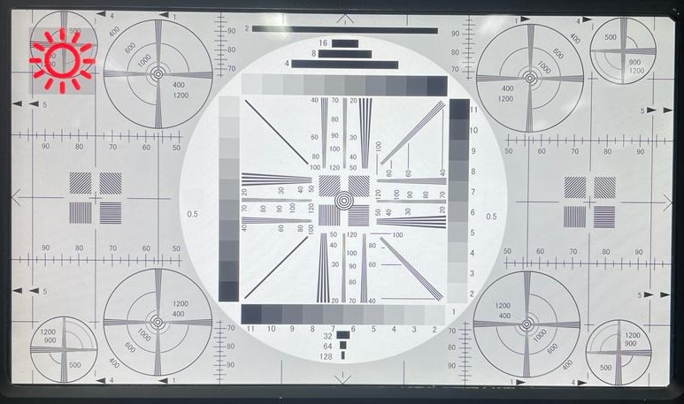 | Able to read the lines and numbers on the red arrow mark.
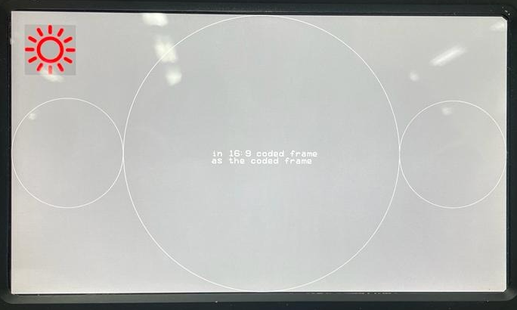 | ASPECT MODE - able to read Ratio 16:9

3.11 Display Contrast Test
Test the VDU display contrast test by the signal generator (VG-871B). Setup the signal generator to MONOSCOPE mode by select “MONOSCOPE” button on the signal generator.
Test Input | Expected Result
Contrast set to 50 (Picture:1)  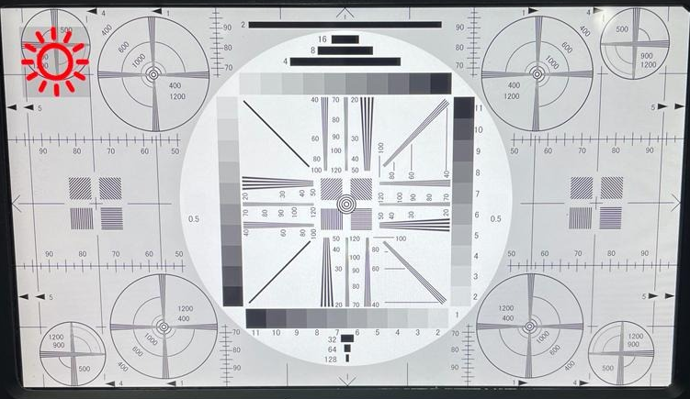 | Able to read the contrast bar level from 1 to 11.
Contrast set to 100 (Picture:2)  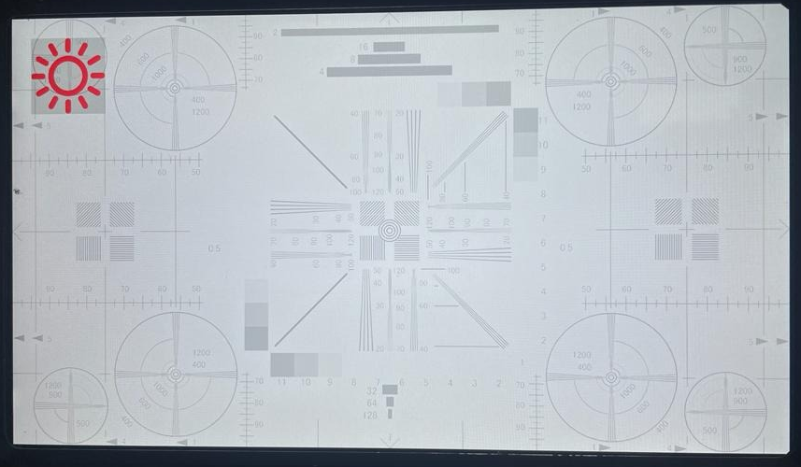 | Able to read the contrast bar level from 9 to 11 at red arrow mark.
Contrast set to 0 (Picture:3)  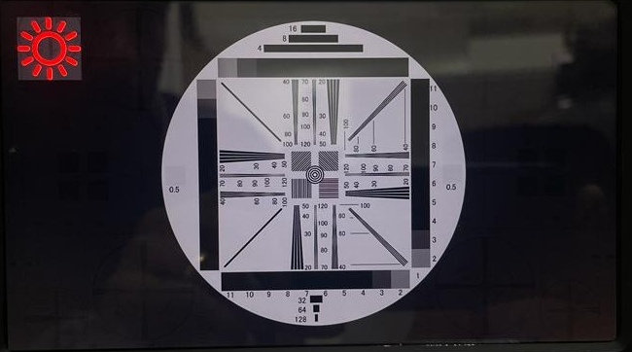 | Able to read the contrast bar level from 1 to 3 at red arrow mark.

3.12 Display Brightness Test
Test the VDU B3 display Brightness test by the signal generator (VG-871B). Setup the signal generator to COLOUR mode by select “WHITE” button on the signal generator. Use the Luminous meter to measure the luminance level of VDU B3 LCD display.
Test Input | Expected Result
brightness set to 0  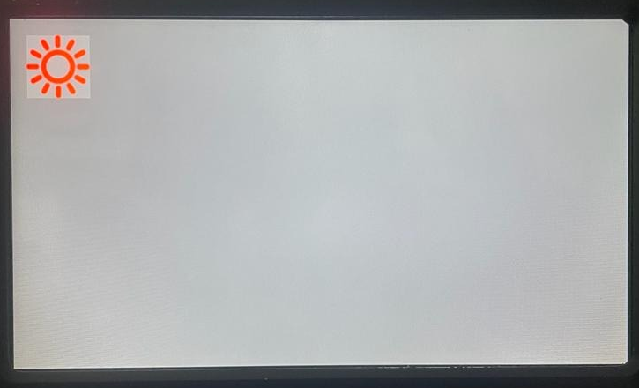 | 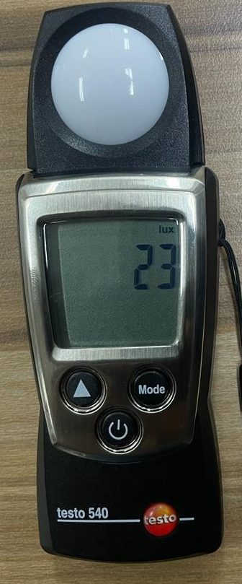 23 Lux
Brightness set to 100  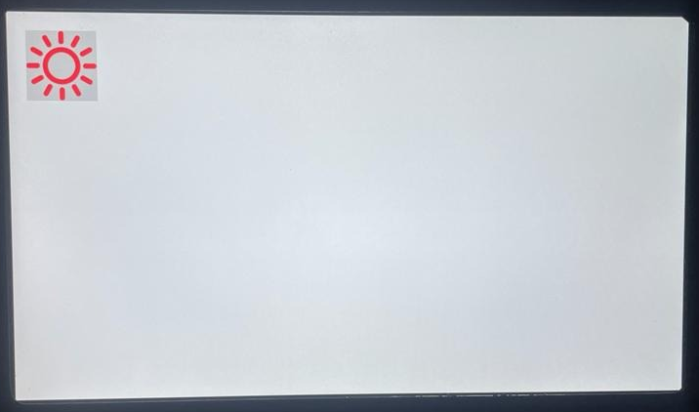 | 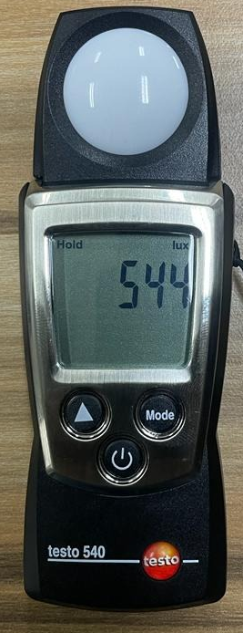 544 LUX

3.13 VDU IO operation test
Panel Discrete Input Button Test
On the PC control button software (Figure 1) to test the VDU B3, consists 9 input buttons. To conduct the functional test and record the results (Appendix 2).

Test Input | Expected Result
Press the Button 1 (Front view) | Current video change to Front view
Press the Button 2 (Rear view) | Current video change to Rear view
Press the Button 3(IR Illuminator) | IR able to control by this button
Press the Button 4 (NUC) | NUC icon existed on the LCD screen
Press the Button 5 (NVG) | NVG function activated
Press the Button 6 (-) | Selection for LCD dimmer
Press the Button 7 (+) | Selection for LCD brightness.
Press the Button 8 (Menu) | To select the menu -Function Setting
Press the Button 9 (Power ON/OFF) | Press 2 sec to power off the VDUB3

Penal Discrete Input Button Test

3.14 RS422 Control Test
Launch “Tera Team” and set com to 115200, 8, N, 1, N. The terminal module able to connect the VDU B3 through the RS422 port to PC terminal. (J1 Connector)
Test Input | Expected Result
Established the connection between VDU J2 connector to PC terminal module (use-RS422 convertor) | Able to read and write in the system.

RS422 Control Test

3.15 USB Debugging port Test
To test the USB debugging port, use the Tera Team test software to test. The terminal module able to connect the VDU B3 through the USB debugging port and read and write (J2 Connector).
Test Input | Expected Result
Established the connection between the VDU B3 connector J1 USB to PC terminal module. | PC terminal module able to read and write the command in the VDU through USB2.0 debugging port without connection issue.
USB2.0 Debugging Port Test

3.16 Ethernet Connection Test
Connect the VDUB3 GigE ports to Laptop, observe the ethernet speed and record test result.
Test Input | Expected Result
Connect and check the Ethernet connection speed status in the PC. | < 1Gbps
Ethernet Connection Test

3.17 System BIT Test

Launch the Tera Team software to setup 115200 and set com to 8, N,1, N to test the firmware version.
- J1 Connector_ USB port to connect the PC terminal.
- Testing Firmware command: b3vdu-stream -v
- Firmware version should be 1 0 1
- Record the result.
Launch the Phyton test software to test the BIT test, Disconnect the SDI inputs individually when system in normal status. The test software would show the corresponding input fault one by one (Figure 1).
- J2 Connector_ RS422 port to connect the PC terminal.
- Record the result
Test Input | Expected Result
Test Input | Legend: Green – Pass /Red- fault
Disconnect the Video Input A and B | Test software show the corresponding input fault.
Mem | Memory log Data IC status
Log | Storage Log Data IC status
Sensor | Power sensor IC status
Power | Current sensor IC Status
Temp | Temp IC status
PWMO | Light Dimmer IC status
PWMA | NA
Key | Key IC status
V out | Video Output channel IC Status
OSD | OSD IC status
RS422 | RS422 IC status
Host | Host IC status

System Bit Test

3.18 Degraded or Emergency operation mode Test
Connect the VDU B3_LCD display to SDI camera or Signal generator.
Select the video generator 1427 select Raster, detail, select colour, make sure that the selected colour on the LCD display.
Disconnect the input video source from the camera VDUB3 sent alert information to the VDU LCD display the screen change to blue screen, no freeze of past images.
    - Power on the system and all the connections should be established.
    - Remove the input video source (A and B) from the VDUB3.
    - Record the result.
Test Input | Expected Result
Disconnect the input video source from the camera | No signal in “Blue” screen on the LCD display panel.

4.0 Visual Inspection & Documentation
Objective | Expected Result
Label Tag Plate and placement (Software & Hardware revision) | Label Tag plate and placement on the E Box. According to drawing revision.
Connector Keyway orientation | Connector J1 & J2 on VDU B2 12 O’ clock according to the drawing.
Documentation | Ensure the ESS Vibration, Temperature reports indicate pass with same serial number tested by ATP.

VDUB3 Test Record Cover sheet
VDUB3 box Serial Number: |  |  | Test Date:

S/W FW Version: | 1.0.1 | HW Version: |  | HW Label Tag: | A

Conducted by: |  |  | Coy: |  | Signature:
Witnessed by: |  |  | Coy: |  | Signature:
Approved by: |  |  | Coy: |  | Signature:
 |  |  |  |  | Date:

S/No | Description of Test | Refer to Procedure | Results |  | Remarks
S/No | Description of Test | Refer to Procedure | Pass | Fail | Remarks
1 | Measure the external dimension (W x H x D) | 3.1
1 | Measure the mass of the Box | 3.1
1 | Mounting Dimension | 3.1
2 | Operating Power | 3.2
3 | System Start up time | 3.3
4 | Reverse polarity test | 3.4
5 | Video latency test | 3.5
6 | Video IO characteristics | 3.6
7 | Video Flickering Test | 3.7
8 | Video Smearing test | 3.8
9 | LCD defects | 3.9
10 | Display resolution test | 3.10
11 | Display contrast test | 3.11
12 | Display Brightness test | 3.12
12 | VDU IO operation Test | 3.13
13 | RS422 Control Test | 3.14
14 | RS232 Debugging port Test | 3.15
15 | Ethernet Connection test | 3.16
16 | System BIT Test | 3.17
17 | Emergency Operation Mode test | 3.18
18 | Visual Inspection & Documentation | 4.0

